

TED UNIVERSITY

Faculty of Engineering

Department of Computer Engineering

**CMPE 360 Computer Graphics– Project 1 Report**

by

Korhan Deniz Akın

18/10/2023

# Introduction

First of all, I would like to say that processing an image with 1024x512 pixels of size was challenging for me to accomplish. Did not know what does int8ClampedArray data type was doing and after I realized that it is used for representing an image by putting its corresponding red, green, blue, and alpha channels into a linear array. This makes the task even harder because these channel values are stored in terms of indices for example, the top left corner pixel’s red channel is the array’s 0th index, the 1stgreen channel, the 2ndindex blue channel, and the 3rd index stores the alpha channel (which is responsible for managing the transparency and opaqueness rate). Thinking of a 2d structure as a 1d data structure with 4 times more pixel size was pretty hard. However, at the end of the day, I managed to complete the task by using the minimum amount of code and with a single while loop.

# Part 1: The Complete Website Page with Lots of Screenshots

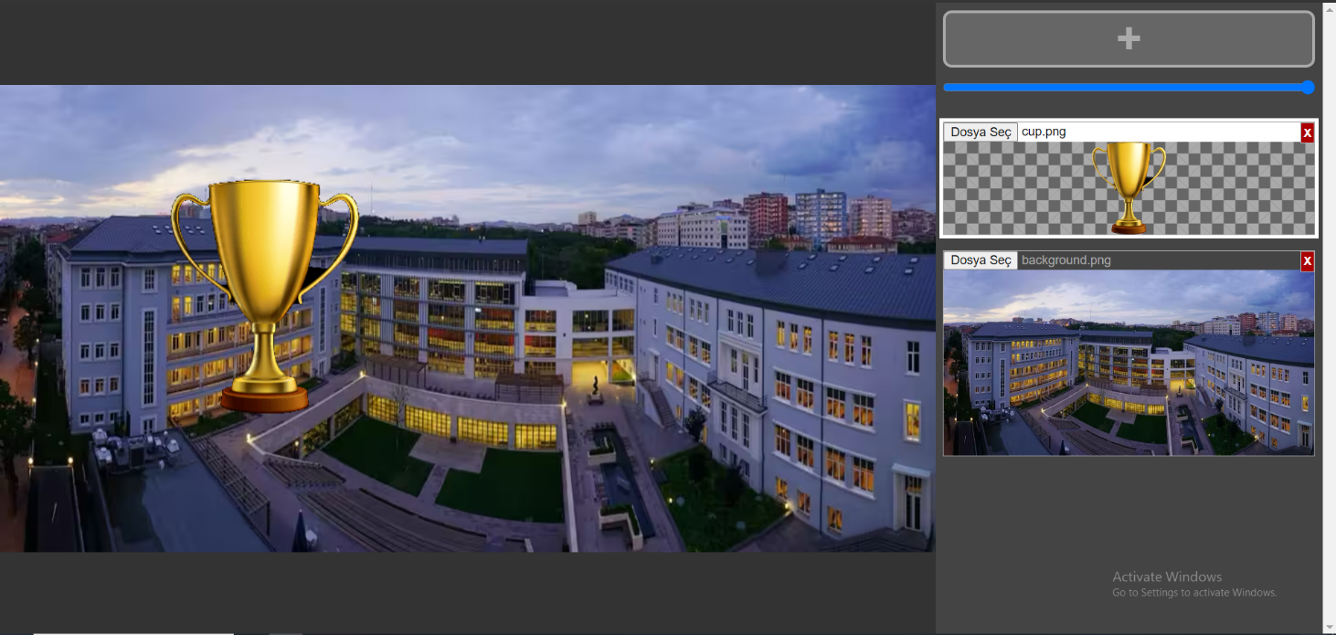For part 1, I will demonstrate the complete functionality by putting some screenshots. In Figure 1 top view of TEDU as background and as a foreground a cup image can be observed. In Figure 2, I wanted to show the drag-and-drop functionality is working as expected.

Figure 1: Background as a top view of TEDU and a cup for a foreground.

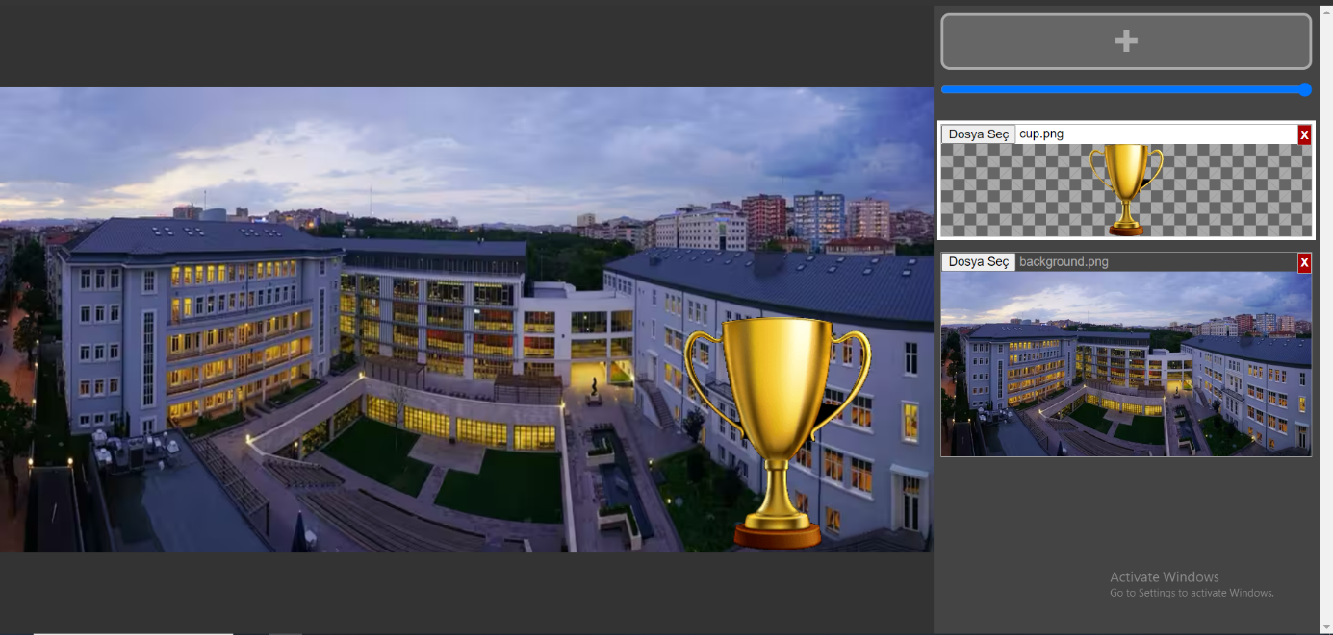Figure 2: Background as a top view of TEDU and a cup for a foreground with drag and drop functionality.

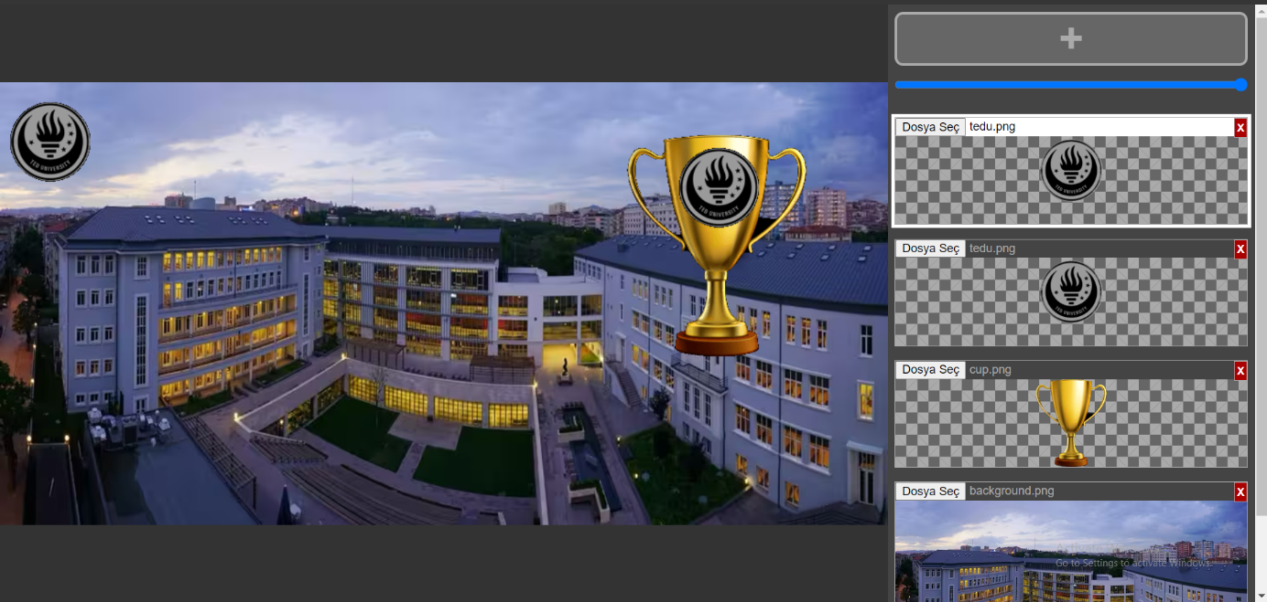In Figure 3, TEDU’s logo is the other foreground on a cup image, and at the top left corner is shown.

Figure 3: 2 TEDU logo added in terms of foreground.

In Figure 4, 5, and 6 transparency and opaqueness (by changing the bar at the top right corner) for all the foreground images and the background images is shown. In Figure 5, I decided to upload another cup image and make it transparent behind the other TEDU logo.

Figure 4: 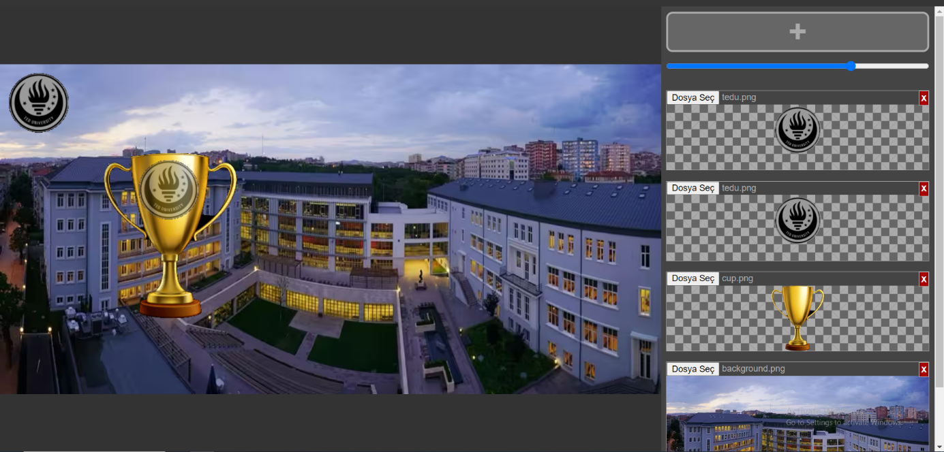Changing transparency or opaqueness properties of the TEDU logo foreground image. Please observe the change in the top right bar compared with Figure 3.

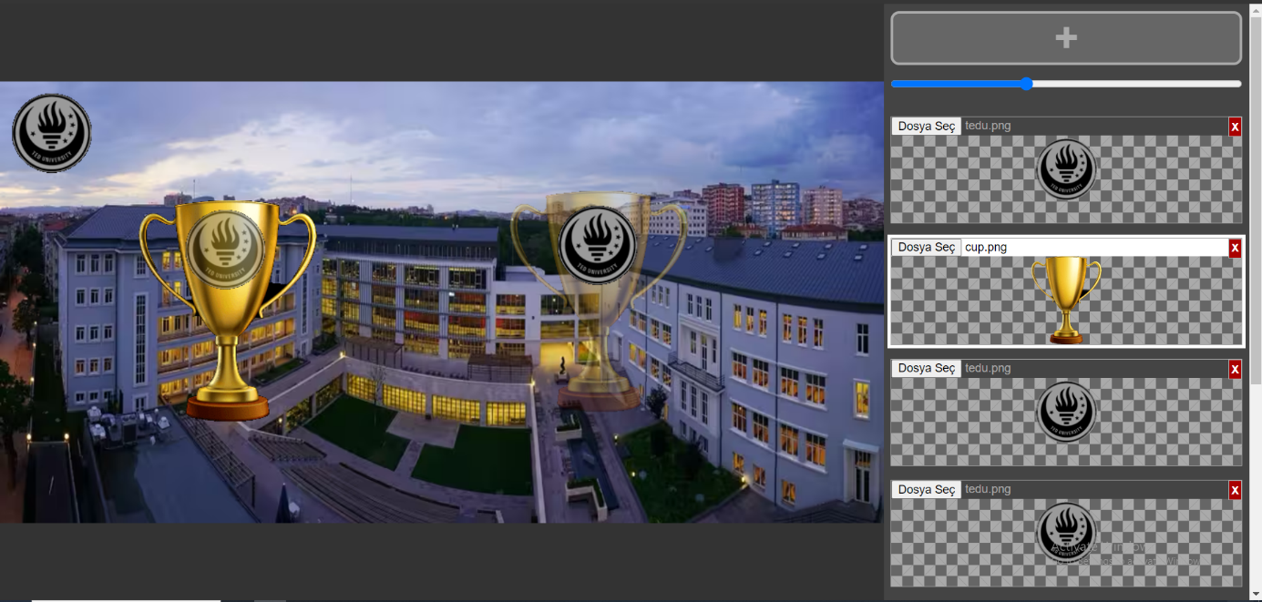

Figure 5: Changing transparency or opaqueness properties of the cup image behind the TEDU logo. 3 images can be overlapped.

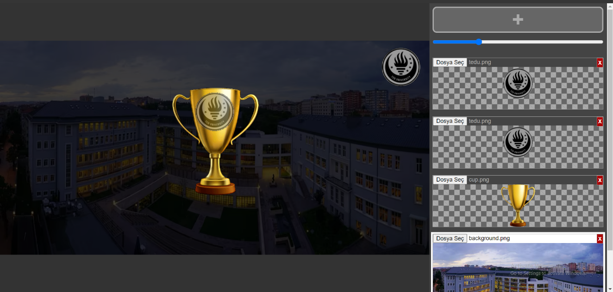Even though it is not a required task I spent another hour to accomplish this, in Figure 6 when we selected the TEDU top view background image as a foreground image, it was also possible to change the opaqueness and transparency properties.

Figure 6: Changing transparency or opaqueness properties of the original background image. All the other images can be observed as desired.

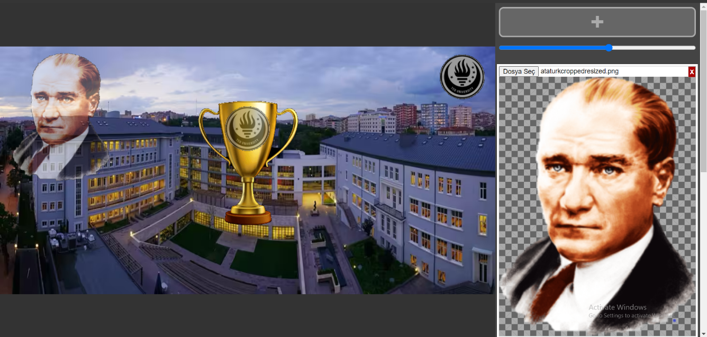To complete the last part, I decided to use Atatürk’s portrait as a foreground image. Downloaded an image and cropped it to obtain a nice .png image format. I added to my page and added some transparency. The final version of the website is shown in Figure 7.

Figure 7: Ataturk’s portrait as a foreground image with added transparency.

# Part 2: Explaining the “Composite” Function

“The Composite Function” located in the “project1.js” file is responsible for overlapping foreground images over background images. It is called from the “project1.html” file several times to obtain the drag-drop functionality. As it is being called inside a loop and using nested loops persistently, might cause a significant impact on the performance. So, using 2 while loops nested caused my browser and even my computer to crash many times.

I mentioned in my introduction part that “int8ClampedArray” has been used to store the image data and it was an efficient but hard-to-visualize approach. However, I managed to do this task with a single loop (to increase the performance) by using 2 pointers:

* “ibg” is responsible for the pixels RGBA (red, green, blue, alpha) channels of the background image.
* “ifg” is responsible for the pixels RGBA channel of the foreground image.

So the thing is, when we see non-zero pixel channel values on the foreground image, we replace them with the pixel channel values of the background image. I increased both ibg and ifg pointers every time 4 indices since 1 pixel is represented with 4 indices in the int8ClampedArray as mentioned. Additionally, for adjusting opacity and transparency properties, I used c = alpha * cforeground + (1-alpha)* cbackground function while I changed the background pixels with foreground and vice versa. This function (pixel coverage, the final pixel that will be displayed) is equivalent to cforeground when alpha=1 and equivalent to cbackground when alpha=0. Alpha values are taken from the bar on the right upper side.

I want to explain further by providing some screenshots of my code. The reason why screenshots are used is because they help to read in a better way the code with some syntax highlighting features of VS Code IDE.

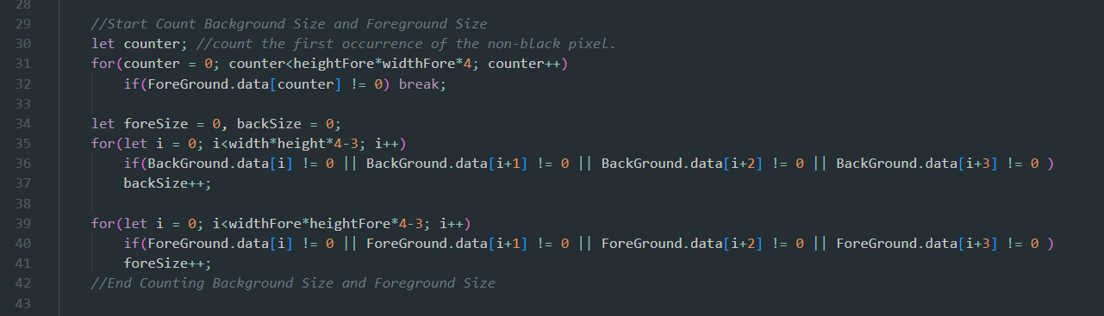In Figure 8, counting the lengths of non-zero pixel values of images to obtain the correct meaning of being a “background” and a “foreground”.

Figure 8: Counting the sizes of background and foreground images.

Figure 9 is crucial since it represents the code that I hold “ForeGroundOpacity” values in an array and compares the last element and 2nd last element. To explain this, imagine that the “composite function ” is being called lots of time from project1.html. If we are to change the alpha value (responsible for transparency and opacity) with the bar and drag-drop the foreground image the composite function is being called all the time. This makes the foreground image slowly disappear from the screen even if we do not change the alpha again because if you multiply any number by 0-1 (0.3 for example) result will be zero after some time. So, only if alpha is changed then change to transparency of the foreground only a single time.

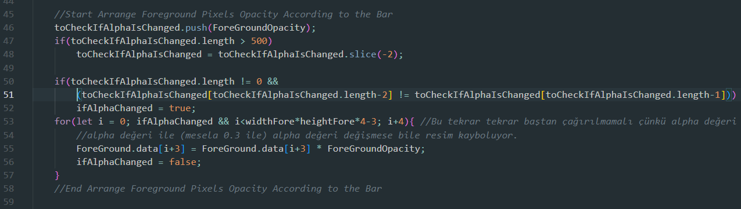

Figure 9: Storing “ForeGroundOpacity” values since several calls of the composite function causes the transparent image to disappear from the screen.

Lastly, to change pixels, the loop is used as mentioned. In Figure 10, I calculated the values for red, green, blue, and alpha values with c = alpha * cforeground + (1-alpha)* cbackground formula. And if a single pixel channel value of foreground is non-zero then we change or find the pixel coverage. With this background and foreground image pixel values are changed in a correct manner that gives us a desired result. In lines 83 and 84, if the foreground image row is finished to be traced then go to the next row of background. It is being done by considering the linear data structure so used: “ibg += (width - widthFore) * 4” formula. Figure 10 is shown at the next page.

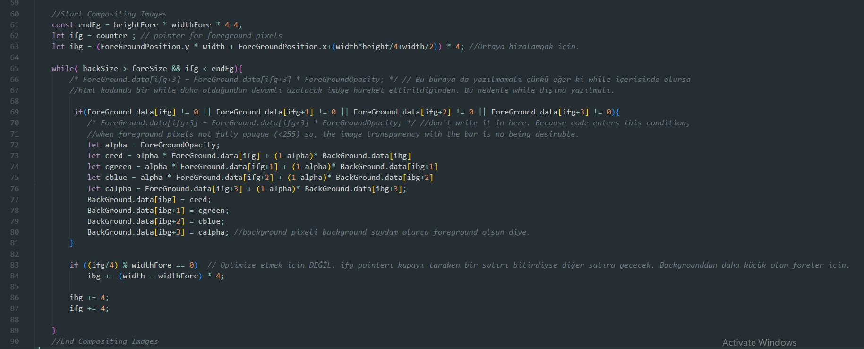Figure 10: Compositing images. The condition is satisfied when the background image is larger than the foreground and the ifg pointer is not finished tracing the foreground image. Change the pixel values of the background image concerning:

“ c = alpha * cforeground + (1-alpha)* cbackground ”

# Conclusion

To conclude, I found the resulting pixel values by comparing foreground and background pixel values by using the alpha channel from the bar by using a linear 8-bit integer array.